**NATIONAL INSTITUTE OF**

**TECHNOLOGY WARANGAL**

 Department of Computer Science and Engineering

**DATABASE MANAGEMENT SYSTEMS**

**PROJECT**

# INVENTORY MANAGEMENT SYSTEM

**Prepared By**:

NAME: ISHIKA JAISWAL

ROLL NO.: 21MMB0A24

---------------------------------------------------------------------------------------------

## Problem Statement

Proper handling of stocks and inventories is imperative for any business to survive and operate. The entirety of retail and wholesale businesses depend completely upon balance between incoming and outgoing stocks/inventory. Inconsistent tracking, warehouse inefficiencies, unorganized data storages, miscalculations, incomplete product information are some of many issues that such businesses face which potentially contributes to completely rupture in their supply-demand structure and their eventual collapse. Without exact information on existing inventory, businesses cannot take correct market decisions and risk over-stocking or under-stocking of inventories while being completely out of phase with the market.

Logically, goods based businesses require proper storage. These storage units (warehouses) must store inventories in an efficient manner as well as provide all crucial information such as durability, expiry and quantity of these stocks. Lack of storage management systems happens to be one of the core problems of all scale businesses. Efficiency is key in shipping stocks out of or placing new stocks into the storage facility. Proper storage management systems in place would only handle the storage part of the business.

These businesses must also find proper markets to sell or trade their inventories. The demand and supply must be coherent with each other. The vulnerability of inventory based businesses has been well defined and exploited by the modern economy. Even though, from the customer’s perspective, these markets are perhaps the most essential; they remain riddled with business-threatening issues within every aspect of it.

Inventory Management System tracks goods throughout the entire supply chain, from purchasing, storage to sales. The overall objective of inventory management is to achieve satisfactory levels of customer service while maintaining supply demand system efficiently. Guaranteeing inventory security while providing proper platform for consumer interactions must be the aim of these systems. After all, suppliers must be able to focus on customer orders with knowledge that the order corresponds to the availability of the products in the storage. This allows suppliers to focus on other important aspects of their business rather than worrying about only protecting the core of it. These systems are revolutionary to the business and perhaps the most important aspect of it.

This Inventory Management System will store information on the supplier. The supplier stores its inventories into the storage facility. The products are all accounted for and stored. The customers of these products connect with employees of the facility. The order details, bills and payment details are also stored into the system. The supplier can not only have inventory security, but also direct contact with the consumers, allowing them to combine both sectors of the business and take correct decisions.

Such management system software are life lines for businesses to cling onto and utilize to its potentials in order to keep up in this modern cybernetic capitalism. With information on all fronts of their business, these suppliers can also use statistical analysis tools for demand forecasting to maintain their supply-demand systems. Stock auditing can be performed on regular basis for accurate information.

## CONTENTS

* Tables
* ER Model Assumptions
* Functional Dependencies and Primary Keys
* Normalization
* ER Diagram
* Relational Schema with Normalized tables
* SQL Code

## TABLES

1. **Customer**

|  |  |  |
| --- | --- | --- |
| **Attribute** | **Data Type** | **Constraints and Characteristics** |
| Customer_ID | VARCHAR2 (20) | Primary Key |
| Customer_name | VARCHAR2 (20) | Composite, Not Null |
| Customer_Phone_No | INT | Multi valued |
| Customer_E_mail | VARCHAR2 (20) | Not Null |
| Staff_ID | VARCHAR2 (20) | Foreign Key, Not Null |
| Order_ID | VARCHAR2 (20) | Foreign key, Not Null |

1. **Employee**

|  |  |  |
| --- | --- | --- |
| **Attribute** | **Data Type** | **Constraints and Characterstics** |
| Employee_ID | VARCHAR2 (20) | Primary Key |
| Employee_Name | VARCHAR2 (20) | Composite , Not Null |
| Employee_Phone_No | INT | Multi valued |
| Employee_Type | VARCHAR2 (20) | Not Null |
| Employee_Scale | Char | Not Null |
| Employee_Title | VARCHAR2 (20) | Not Null |

1. **Order**

|  |  |  |
| --- | --- | --- |
| **Attribute** | **Data Type** | **Constraints and Characteristics** |
| Order_ID | VARCHAR2 (20) | Primary Key |
| Staff_ID | VARCHAR2 (20) | Foreign key, Not Null |
| Customer_ID | VARCHAR2 (20) | Foreign Key, Not Null |
| Order_Details_ID | VARCHAR2 (20) | Foreign key, Not Null |

1. **Order Details**

|  |  |  |
| --- | --- | --- |
| **Attribute** | **Data Type** | **Constraints and Characteristics** |
| Order_Details_ID | VARCHAR2 (20) | Primary Key |
| Order_Date | DATE | Not Null |
| Order_Bill_No | INT | Not Null |
| Order_Discount | INT | - |
| Order_Quantity | INT | Not Null |
| Product_ID | VARCHAR2 (20) | Foreign Key, Not Null |

1. **Order Relationship**

|  |  |  |
| --- | --- | --- |
| **Attribute** | **Data Type** | **Constraints and Characteristics** |
| Customer_ID | VARCHAR2 (20) | Foreign Key |
| Order_ID | VARCHAR2 (20) | Foreign Key |

1. **Payment**

|  |  |  |
| --- | --- | --- |
| **Attribute** | **Data Type** | **Constraints and Characteristics** |
| Payment_Bill_No | INT | Primary Key |
| Payment_Type | VARCHAR2(20) | Not Null |
| Payment_Due_Date | DATE | Not Null |
| Payment_Date | DATE | Not Null |
| Payment_Amount | INT | Not Null |
| Order_Details_ID | VARCHAR2 (20) | Foreign Key, Not Null |

1. **Supplier**

|  |  |  |
| --- | --- | --- |
| **Attribute** | **Data Type** | **Constraints and Characteristics** |
| Supplier_ID | VARCHAR2 (20) | Primary Key |
| Supplier_Name | VARCHAR2 (20) | Composite, Not Null |
| Supplier_Phone_No | INT | Multi valued |
| Supplier_Discount | INT | - |
| Supplier_Pay_Method | VARCHAR2 (20) | Not Null |
| Product_ID | VARCHAR2 (20) | Foreign Key, Not Null |
| Supplier_Total_Product | INT | Not Null |

1. **Product**

|  |  |  |
| --- | --- | --- |
| **Attribute** | **Data type** | **Constraints and Characteristics** |
| Product_ID | VARCHAR2 (20) | Primary Key |
| Product_Name | VARCHAR2(20) | Not Null |
| In_Stock | VARCHAR2(20) | Not Null |
| Product_Price | INT | Not Null |
| Product_Description | VARCHAR2 (20) | Not Null |
| Supplier_ID | VARCHAR2 (20) | Foreign key, Not Null |
| Category_ID | VARCHAR2 (20) | Foreign Key, Not Null |
| Order_Details_ID | VARCHAR2 (20) | Foreign key, Not Null |

1. **Category**

|  |  |  |
| --- | --- | --- |
| **Attribute** | **Data Type** | **Constraints and Characteristics** |
| Category_ID | VARCHAR2 (20) | Primary Key |
| Category_Name | VARCHAR2(20) | Not Null |
| Category_Description | VARCHAR2(20) | Not Null |

1. **Supplier_Phone_No**

|  |  |  |
| --- | --- | --- |
| **Attribute** | **Data Type** | **Constraints and Characteristics** |
| Supplier_ID | VARCHAR2 (20) | Primary Key |
| Phone_no | INT | Not Null |

1. **Employee_Phone_No**

|  |  |  |
| --- | --- | --- |
| **Attribute** | **Data Type** | **Constraints and Characteristics** |
| Employee_ID | VARCHAR2 (20) | Primary Key |
| Phone_no | INT | Not Null |

1. **Customer_Phone_No**

|  |  |  |
| --- | --- | --- |
| **Attribute** | **Data Type** | **Constraints and Characteristics** |
| Customer_ID | VARCHAR2 (20) | Primary Key |
| Phone_no | INT | Not Null |

1. **Supplies**

|  |  |  |
| --- | --- | --- |
| **Attribute** | **Data Type** | **Constraints and Characteristics** |
| S_ID | VARCHAR2 (20) | Primary Key, Foreign  Key |
| P_ID | VARCHAR2 (20) | Foreign Key |

1. **Contains**

|  |  |  |
| --- | --- | --- |
| **Attribute** | **Data Type** | **Constraints and Characteristics** |
| Product_ID | VARCHAR2 (20) | Foreign Key |
| Oder_details_ID | VARCHAR2 (20) | Foreign Key |

## ER-MODEL ASSUMPTIONS

* A supplier can store any number of different products. The products are not unique to the supplier and any product can have more than one supplier.
* Each and every of these products must belong to one category only. However, each category can have any quantity of products.
* Each customer who visits the system must be accompanied by a facility employee. An employee can only issue product orders. The employee can serve any number of customers at any given time.
* Each employee can issue any number of customer’s product orders. Each of these orders are unique and must be traced back to unique issuing employee.
* A customer is free to place any number of different orders into the system.

Each order details must correspond to each customer.

* Each order has order details specific to it. The same order details can have more than one product.
* Each payment receipt will correspond to one set of order details. Similarly, each set of order details can produce one payment receipt.
* Each order details may contain any number of products, as per the demand.

Similarly, any product can be present in any number of order details.

## FUNCTIONAL DEPENDENCIES AND PRIMARY KEY

* **Customer**

Customer_ID-> {Customer_Name,Customer_Email,Staff_ID,Order_ID} Since all the fields depend on Customer_ID, (Customer_ID) + -> R.

Hence, Customer_ID is Primary Key.

* **Employee**

Employee_ID ->

{Employee_Name,Employee_Type,Employee_Scale,Employee_Title} Since all the fields depend on Employee_ID, (Employee_ID)+ -> R.

Hence, Employee_ID is Primary Key.

* **Order**

Order_ID -> {Staff_ID,Customer_ID,Order_Details_ID} Since all the fields depend on Order_ID, (Order_ID)+ -> R.

Hence, Order_ID is Primary Key.

* **Order Details**

Order_Details_ID ->

{Order_Date,COrder_Bill_No,Order_Discount,Order_Quantity,Product_ID} Since all the fields depend on Order_Details_ID, (Order_Details_ID)+ -> R.

Hence, Order_Details_ID is Primary Key.

* **Payment**

Payment_Bill_No->

{Payment_Type,Payment_Due_Date,Payment_Date,Payemnt_Amount,Order_Det ails_ID}

Since all the fields depend on Payment_Bill_No, (Payment_Bill_No)+ -> R.

Hence, Payment_Bill_No is Primary Key.

* **Supplier**

Supplier_ID ->

{Supplier_Name,Supplier_Discount,Supplier_Pay_Method,Product_ID,Supplier_T otal_Product}

Since all the fields depend on Supplier_ID, (Supplier_ID)+ -> R.

Hence, Supplier_ID is Primary Key.

* **Product**

Product_ID ->

{Product_Name,In_Stocks,Product_Price,Product_Description,Supplier_ID,Categ ory_ID,Order_Details_ID}

Since all the fields depend on Product_ID, (Product_ID)+ -> R.

Hence, Product_ID is Primary Key.

* **Category**

Category_ID -> {Customer_Name,Customer_Description} Since all the fields depend on Category_ID, (Category_ID)+ -> R.

Hence, Category_ID is Primary Key.

* Supplier_Phone_No

Supplier_ID ->{Supplier_Phone_no}

Since Supplier_Phone_No depend on the Supplier_ID, (Supplier_ID)+ -> R. Hence, Supplier_ID is Primary Key.

* Employee_Phone_No

Employee_ID ->{Employee_Phone_no}

Since Employee_Phone_No depend on the Employee_ID, (Employee_ID)+ -> R.

Hence, Employee_ID is Primary Key.

* Customer_Phone_No

Customer_ID ->{Customer_Phone_no}

Since Customer_Phone_No depend on the Customer_ID, (Customer_ID)+ -> R.

Hence, Customer_ID is Primary Key.

* Supplies

S_ID ->{P-ID}

Since all the fields depend on S_ID, (S_ID)+ -> R.

Hence, S_ID is Primary Key.

## NORMALISATION

* **Customer**

Primary key: Customer_ID

Attribute Phone_nois Multivalued hence has another table of its own so the table is in 1NF.

All attributes depend on the Customer_ID, hence the table is 2NF.

All attributes depend directly on Customer_ID, hence the table is in 3NF.

All determinants (Customer_ID) are candidate keys, hence the table is in BCNF.

* **Employee**

Primary key: Employee_ID

Attribute Phone_nois Multivalued hence has another table of its own so the table is in 1NF.

All attributes depend on the Employee _ID, hence the table is 2NF.

All attributes depend directly on Employee _ID, hence the table is in 3NF.

All determinants (Employee _ID) are candidate keys, hence the table is in BCNF.

* **Order**

Primary key: Order_ID

All attributes depend on the Order _ID, hence the table is 2NF.

All attributes depend directly on Order _ID, hence the table is in 3NF.

All determinants (Order _ID) are candidate keys, hence the table is in BCNF.

* **Order Details**

Primary key: Order_Details _ID

All attributes depend on the Customer_ID, hence the table is 2NF.

All attributes depend directly on Customer_ID, hence the table is in 3NF.

All determinants (Customer_ID) are candidate keys, hence the table is in

BCNF.

* **Payment**

Primary key: Payment_Bill_No

All attributes depend on the Payment_Bill_No, hence the table is 2NF.

All attributes depend directly on Payment_Bill_No, hence the table is in 3NF.

All determinants (Payment_Bill_No) are candidate keys, hence the table is in BCNF.

* **Supplier**

Primary key: Supplier_ID

Attribute Phone_nois Multivalued hence has another table of its own so the table is in 1NF.

All attributes depend on the Supplier_ID, hence the table is 2NF.

All attributes depend directly on Supplier_ID, hence the table is in 3NF.

All determinants (Supplier_ID) are candidate keys, hence the table is in BCNF.

* **Product**

Primary key: Product_ID

All attributes depend on the Product_ID, hence the table is 2NF.

All attributes depend directly on Product_ID, hence the table is in 3NF.

All determinants (Product_ID) are candidate keys, hence the table is in BCNF.

* **Category**

Primary key: Category_ID

All attributes depend on the Category_ID , hence the table is 2NF.

All attributes depend directly on Category_ID , hence the table is in 3NF.

All determinants (Category_ID) are candidate keys, hence the table is in BCNF.

* **Employee_Phone_no**

All attributes depend on the Employee_ID , hence the table is 2NF.

All attributes depend directly on Employee_ID , hence the table is in 3NF.

All determinants (Employee_ID) are candidate keys, hence the table is in BCNF.

* **Customer_Phone_no**

All attributes depend on theCustomer _ID , hence the table is 2NF.

All attributes depend directly on Customer _ID , hence the table is in 3NF.

All determinants (Customer _ID) are candidate keys, hence the table is in BCNF.

* **Supplier_Phone_no**

All attributes depend on theSupplier _ID , hence the table is 2NF.

All attributes depend directly on Supplier_ID , hence the table is in 3NF.

All determinants (Supplier _ID) are candidate keys, hence the table is in

BCNF.

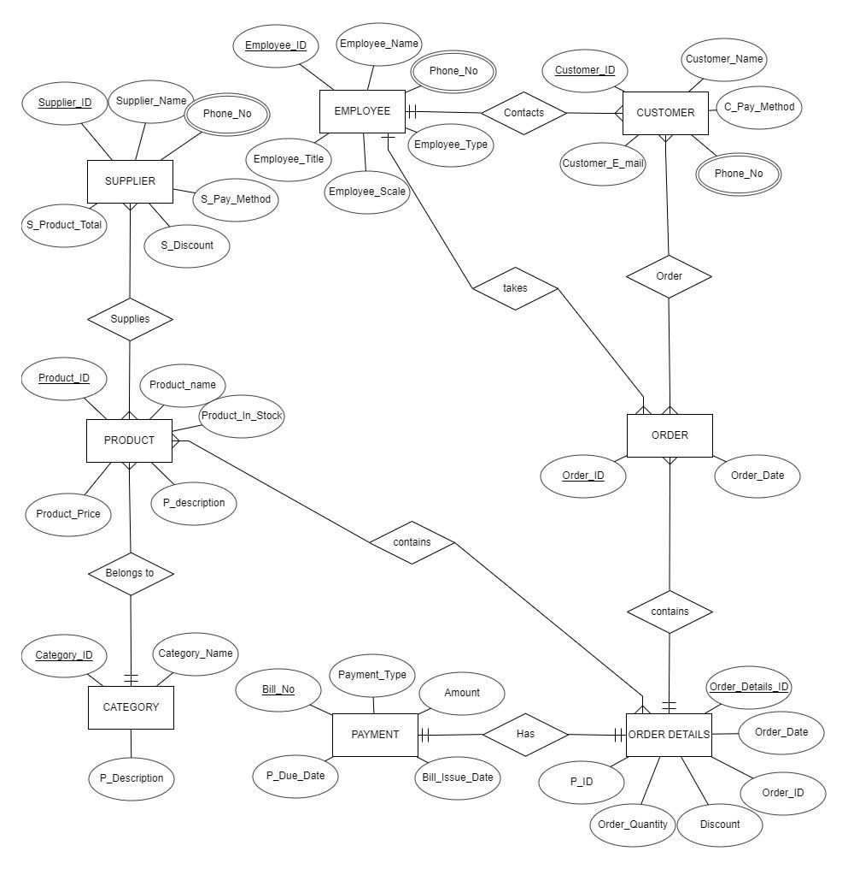**ER DIAGRAM**

### RELATIONAL SCHEMA

**SQL CODE :**

CREATE TABLE EMPLOYEE(

Employee_ID VARCHAR (20) PRIMARY KEY,

Employee_NameVARCHAR(20) NOT NULL,

Emplyee_TypeVARCHAR(20) NOT NULL,

Employee_ScaleVARCHAR(20) NOT NULL,

Employee_Title VARCHAR (20) NOT NULL

);

CREATE TABLE CATEGORY

(

Category_ID VARCHAR (20) PRIMARY KEY,

Category_Name VARCHAR (20) NOT NULL,

Category_Description VARCHAR (20) NOT NULL

);

CREATE TABLE PRODUCT

(

Product_ID VARCHAR (20) PRIMARY KEY,

Product_Name VARCHAR (20) NOT NULL,

In_Stock VARCHAR (20) NOT NULL, Product_Price INT NOT NULL,

Product_Description VARCHAR (20) NOT NULL,

Supplier_ID VARCHAR (20) NOT NULL,

Category_ID VARCHAR (20) NOT NULL,

Order_Details_ID VARCHAR (20) NOT NULL,

FOREIGN KEY (Category_ID) REFERENCES CATEGORY(Category_ID)

);

CREATE TABLE ORDER_DETAILS

(

Order_Details_ID VARCHAR (20) PRIMARY KEY,

Order_Date DATE NOT NULL,

Order_Bill_No INT NOT NULL,

Order_Discount INT,

Order_Quantity INT,

Product_ID VARCHAR (20) NOT NULL,

FOREIGN KEY (Product_ID) REFERENCES PRODUCT (Product_ID)

);

CREATE TABLE PAYMENT

(

Payment_Bill_No INT PRIMARY KEY,

Payment_Type VARCHAR (20) NOT NULL,

Payment_Due_Date DATE NOT NULL,

Bill_Issue_Date DATE NOT NULL,

Payment_Amount INT NOT NULL,

Order_Details_ID VARCHAR (20) NOT NULL,

FOREIGN KEY (Order_Details_ID) REFERENCES ORDER_DETAILS (Order_Details_ID)

);

CREATE TABLE SUPPLIER

(

Supplier_ID VARCHAR (20) PRIMARY KEY,

Supplier_Name VARCHAR (20) NOT NULL,

Supplier_Discount INT,

Supplier_Pay_Method VARCHAR (20) NOT NULL,

Product_ID VARCHAR (20) NOT NULL,

Supplier_Total INT,

FOREIGN KEY (Product_ID) REFERENCES PRODUCT(Product_ID)

);

CREATE TABLE CUSTOMER

(

Customer_ID VARCHAR (20) PRIMARY KEY,

Customer _Name VARCHAR (20) NOT NULL,

Customer_Email VARCHAR (20),

Staff_ID VARCHAR (20) NOT NULL,

Order_ID VARCHAR (20) NOT NULL,

FOREIGN KEY (Staff_ID) REFERENCES EMPLOYEE(Employee_ID)

);

CREATE TABLE ORDER_

(

Order_ID VARCHAR (20) PRIMARY KEY,

Staff_ID VARCHAR (20) NOT NULL,

Customer_ID VARCHAR (20) NOT NULL,

Order_Details_ID VARCHAR (20) NOT NULL,

FOREIGN KEY (Staff_ID) REFERENCES EMPLOYEE (Employee_ID),

FOREIGN KEY (Customer_ID) REFERENCES CUSTOMER(CUSTOMER_ID)

);

CREATE TABLE CUSTOMER_PHONE_NO

(

Phone_no INT NOT NULL,

Customer_ID VARCHAR (20) PRIMARY KEY,

FOREIGN KEY (Customer_ID) REFERENCES CUSTOMER(CUSTOMER_ID)

);

CREATE TABLE EMPLOYEE_PHONE_NO

(

Phone_no INT NOT NULL,

Employee_ID VARCHAR (20) PRIMARY KEY,

FOREIGN KEY (Employee_ID) REFERENCES EMPLOYEE(EMPLOYEE_ID)

);

CREATE TABLE SUPPLIER_PHONE_NO

(

Phone_no INT NOT NULL,

Supplier_ID VARCHAR (20) PRIMARY KEY,

FOREIGN KEY (Supplier_ID) REFERENCES SUPPLIER(SUPPLIER_ID)

);

CREATE TABLE CONTAINS

(

Order_Details_ID VARCHAR (20) NOT NULL,

Product_ID VARCHAR (20) NOT NULL,

FOREIGN KEY (Order_Details_ID) REFERENCES

PRODUCT(Order_Details_ID)

FOREIGN KEY (Customer_ID) REFERENCES CUSTOMER(CUSTOMER_ID)

);

INSERT INTO SUPPLIER VALUES ('1001A','Ederson Moraes', 'Credit Card',' 1 %', 200000);

INSERT INTO SUPPLIER VALUES ('002B','Kyle Walker', 'Electronic Wallet',' 3 %', 250000);

INSERT INTO SUPPLIER VALUES ('003C','Ruben Dias', 'Credit Card','5 %', 200000);

INSERT INTO SUPPLIER VALUES ('004D','Vincent Kompany','Bank Transfer',' 6 %', 195000);

INSERT INTO SUPPLIER VALUES ('005A','John Stones', 'Credit Card',' 4 %', 80000);

INSERT INTO SUPPLIER VALUES ('006B','Nathan Ake', 'Credit Card',' 10 %', 90000);

INSERT INTO SUPPLIER VALUES ('017C','Kevin De Bruyne', 'Electronic Wallet',' 15 %', 300000);

INSERT INTO SUPPLIER VALUES ('009D','Mike Hunt', 'Bank Transfer',' 2 %', 50000);

INSERT INTO SUPPLIER VALUES ('010A','Sergio Aguero', 'Bank Transfer',' 10%', 195000);

INSERT INTO SUPPLIER VALUES ('011C','Dixie Normous', 'Credit Card',' 8 %', 455800);

INSERT INTO EMPLOYEE VALUES ('E001','Kiran Limbu', 'Full Time',10, 'Customer Service');

INSERT INTO EMPLOYEE VALUES ('E002','Rohit Chand', 'Part Time',10, 'Warehouse Manager');

INSERT INTO EMPLOYEE VALUES ('E003','Anjan Bista', 'Full Time',10, 'Sales Manager');

INSERT INTO EMPLOYEE VALUES ('E004','Sunil Bal', 'Casual',9, 'Warehouse

Assistant ');

INSERT INTO EMPLOYEE VALUES ('E005','Bimal Gharti ', 'Full',9, 'Customer Service');

INSERT INTO EMPLOYEE VALUES ('E006','Biraj Maharjan', 'Full Time',10, 'Accountant');

INSERT INTO EMPLOYEE VALUES ('E007','Bharat Khawas', 'Casual',10, 'Warehouse Assistant');

INSERT INTO EMPLOYEE VALUES ('E008','Ram Shrestha', 'Part Time',9, 'Customer Service');

INSERT INTO EMPLOYEE VALUES ('E009','Abhisheko Rijal', 'Full Time',9, 'Customer Service');

INSERT INTO EMPLOYEE VALUES ('E010','Bikesh Kutthu', 'Full Time',10, 'Customer Service');

INSERT INTO CUSTOMER VALUES ('C001',' Hero Hiralal', 'Electronic Wallet', 'hiralal@gmail.com', 'E005');

INSERT INTO CUSTOMER VALUES ('C002',' UdayShetty', 'Bank Transfer', 'shettyuday@gmail.com', 'E009');

INSERT INTO CUSTOMER VALUES ('C003',' MajnuShetty', 'Phone Wallet', 'shettymaj@gmail.com', 'E010');

INSERT INTO CUSTOMER VALUES ('C004',' Ghunghroo Seth', 'Credit card', 'hamro@gmail.com', 'E008');

INSERT INTO CUSTOMER VALUES ('C005',' Lucky Khan', 'Credit Card', 'mero@gmail.com', 'E005');

INSERT INTO CUSTOMER VALUES ('C006',' Rajesh Hamal', 'Electronic Wallet', 'tero@gmail.com', 'E008');

INSERT INTO CUSTOMER VALUES ('C007',' AkshayKhanna', 'Electronic Wallet', 'tyesko@gmail.com', 'E005');

INSERT INTO CUSTOMER VALUES ('C008',' BaburaoApte', 'Bank Transfer', 'esko@gmail.com', 'E010');

INSERT INTO CUSTOMER VALUES ('C009',' ShyamKafle', 'Credit card', 'tapaiko@gmail.com', 'E009');

INSERT INTO CUSTOMER VALUES ('`C010',' Kachra Seth', 'Credit Card', 'kosaiko@gmail.com', 'E008');

INSERT INTO PRODUCT VALUES ('P01','beverage','Pepsi',70, 300, '002F');

INSERT INTO PRODUCT VALUES ('P02','beverage','Rasna',50, 275, '002F');

INSERT INTO PRODUCT VALUES ('P03','beverage','Coke',65, 300, '002F');

INSERT INTO PRODUCT VALUES ('P04', 'beverage','Mirinda',65, 250, '002F');

INSERT INTO PRODUCT VALUES ('P05','stationary','GlueStick',20, 400, '007A');

INSERT INTO PRODUCT VALUES ('P06', 'stationary','Stapler',100, 100, '007A');

INSERT INTO PRODUCT VALUES ('P07','stationary','Box',250, 150, '007A');

INSERT INTO PRODUCT VALUES ('P08', 'Cosmetics','deodrant',400, 100, '004A');

INSERT INTO PRODUCT VALUES ('P09', 'Cosmetics','hairbrush',250, 50, '004A');

INSERT INTO PRODUCT VALUES ('P10', 'Cosmetics','Nailclipper',100, 50, '004A');

INSERT INTO PRODUCT VALUES ('P11', 'Electronics','Mixergrinder',3000, 25, '005A');

INSERT INTO PRODUCT VALUES ('P12', 'Electronics','Speaker',2500, 40, '005A');

INSERT INTO ORDER_ ('OR01','2021-01-06','D010','E007'); INSERT INTO ORDER_ ('OR02','2021-03-07','D005','E005'); INSERT INTO ORDER_ ('OR03','2021-05-10','D001','E009'); INSERT INTO ORDER_ ('OR04','2021-05-13','D004','E010'); INSERT INTO ORDER_ ('OR05','2021-03-26','D003','E006'); INSERT INTO ORDER_ ('OR06','2021-01-08','D005','E007'); INSERT INTO ORDER_ ('OR07','2021-04-01','D006','E009'); INSERT INTO ORDER_ ('OR08','2021-02-12','D005','E008'); INSERT INTO ORDER_ ('OR09','2021-02-06','D007','E010'); INSERT INTO ORDER_ ('OR10','2021-03-05','D004','E007');

INSERT INTO ORDER_DETAILS VALUES ('D001','P02', 30, '2021-02-03','2 %', 1010);

INSERT INTO ORDER_DETAILS VALUES ('D002','P03', 40, '2021-04-03','3 %', 1003);

INSERT INTO ORDER_DETAILS VALUES ('D003','P04', 100, '2021-05-05','5 %', 1002);

INSERT INTO ORDER_DETAILS VALUES ('D004','P10', 50, '2021-0612','10%', 1004);

INSERT INTO ORDER_DETAILS VALUES ('D005','P12', 70, '2021-07-14','4 %', 1005);

INSERT INTO ORDER_DETAILS VALUES ('D006','P07', 34, '2021-09-06','3 %', 1006);

INSERT INTO ORDER_DETAILS VALUES ('D007','P08', 19, '2021-08-29','6 %', 1007);

INSERT INTO ORDER_DETAILS VALUES ('D008','P09', 40, '2021-10-05','1 %', 1008);

INSERT INTO ORDER_DETAILS VALUES ('D009','P11', 55, '2021-11-03','2 %', 1009);

INSERT INTO PAYMENT VALUES (1001,' Bank Transfer', 150000, '2021-0203', '2021-02-05');

INSERT INTO PAYMENT VALUES (1002,' Electronic Wallet', 230000, '202102-04', '2021-04-05');

INSERT INTO PAYMENT VALUES (1003,' Credit Card', 15000, '2021-02-05', '2021-04-05');

INSERT INTO PAYMENT VALUES (1004,' Bank Transfer', 23888, '2021-02-06', '2021-04-05');

INSERT INTO PAYMENT VALUES (1005,' Electronic Wallet', 230000, '202102-07', '2021-04-05');

INSERT INTO PAYMENT VALUES (1006,' Bank Transfer', 100000, '2021-0208', '2021-04-05');

INSERT INTO PAYMENT VALUES (1007,' Credit Card', 18776, '2021-02-09', '2021-05-05');

INSERT INTO PAYMENT VALUES (1008,' Bank Transfer', 25000, '2021-02-10', '2021-06-05');

INSERT INTO PAYMENT VALUES (1009,' Electronic Wallet', 10000, '2021-0211', '2021-03-05');

INSERT INTO PAYMENT VALUES (1010,' Credit Card', 15000, '2021-02-12', '2021-04-05');

INSERT INTO SUPPLIER_PHONE_NO VALUES ('1001A',009779860276223);

INSERT INTO SUPPLIER_PHONE_NO VALUES ('002B',00917386925833); INSERT INTO SUPPLIER_PHONE_NO VALUES ('002B',00917335945845);

INSERT INTO SUPPLIER_PHONE_NO VALUES ('003C',009779851091932);

INSERT INTO SUPPLIER_PHONE_NO VALUES ('004D',497879208984);

INSERT INTO SUPPLIER_PHONE_NO VALUES ('005A',413144312141);

INSERT INTO SUPPLIER_PHONE_NO VALUES ('006B',41341243422);

INSERT INTO SUPPLIER_PHONE_NO VALUES ('017C',0123124981293);

INSERT INTO SUPPLIER_PHONE_NO VALUES ('009D',87288992892);

INSERT INTO SUPPLIER_PHONE_NO VALUES ('011C',00917782827234);

INSERT INTO EMPLOYEE_PHONE_NO VALUES ('E001' ,781267881982);

INSERT INTO EMPLOYEE_PHONE_NO VALUES ('E001' ,67156728222);

INSERT INTO EMPLOYEE_PHONE_NO VALUES ('E002' ,82762788389);

INSERT INTO EMPLOYEE_PHONE_NO VALUES ('E003' ,9727882323); INSERT INTO EMPLOYEE_PHONE_NO VALUES ('E004' ,8825677822); INSERT INTO EMPLOYEE_PHONE_NO VALUES ('E005' ,2313525453);

INSERT INTO EMPLOYEE_PHONE_NO VALUES ('E006' ,356425235235);

INSERT INTO EMPLOYEE_PHONE_NO VALUES ('E007' ,5231354254534);

INSERT INTO EMPLOYEE_PHONE_NO VALUES ('E008' ,8738839933);

INSERT INTO EMPLOYEE_PHONE_NO VALUES ('E009' , 8912734891274901);

INSERT INTO EMPLOYEE_PHONE_NO VALUES ('E009' ,981249124);

INSERT INTO EMPLOYEE_PHONE_NO VALUES ('E010' ,2431413531);

INSERT INTO CUSTOMER_PHONE_NO VALUES ('C001' ,00917386925833); INSERT INTO CUSTOMER_PHONE_NO VALUES ('C002' ,87923491274012); INSERT INTO CUSTOMER_PHONE_NO VALUES ('C003' ,87124981273908);

INSERT INTO CUSTOMER_PHONE_NO VALUES ('C004' , 783498149128414);

INSERT INTO CUSTOMER_PHONE_NO VALUES ('C005' , 982739812371280);

INSERT INTO CUSTOMER_PHONE_NO VALUES ('C006' , 981278912323321);

INSERT INTO CUSTOMER_PHONE_NO VALUES ('C007' ,8912738912723);

INSERT INTO CUSTOMER_PHONE_NO VALUES ('C008' ,98123091283210);

INSERT INTO CUSTOMER_PHONE_NO VALUES ('C009' , 981273012312312);

INSERT INTO CUSTOMER_PHONE_NO VALUES ('C010' , 900283091223121);

SOME TABLES FROM WORKING DATABASE

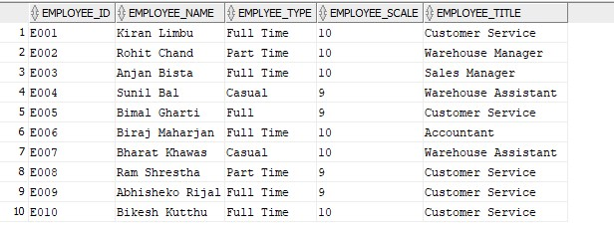

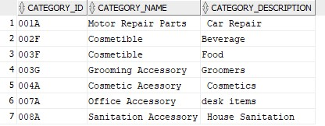

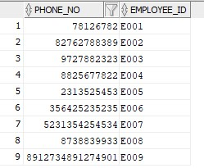

## **THE END**